1. 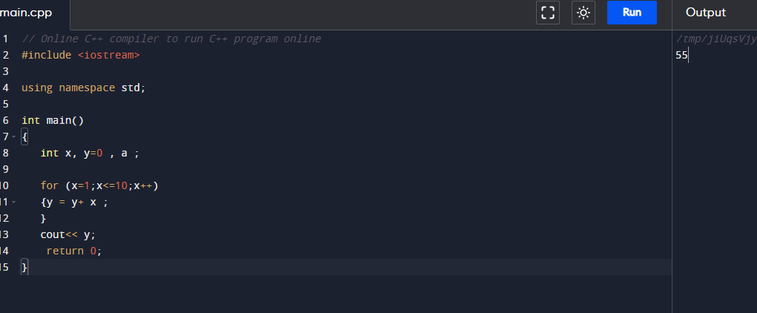Write a program in C++ to find the sum of first 10 natural numbers.

#include <iostream>

using namespace std;

int main()

{

int x, y=0 , a ;

for (x=1;x<=10;x++)

{y = y+ x ;

}

cout<< y;

return 0;

}

1. 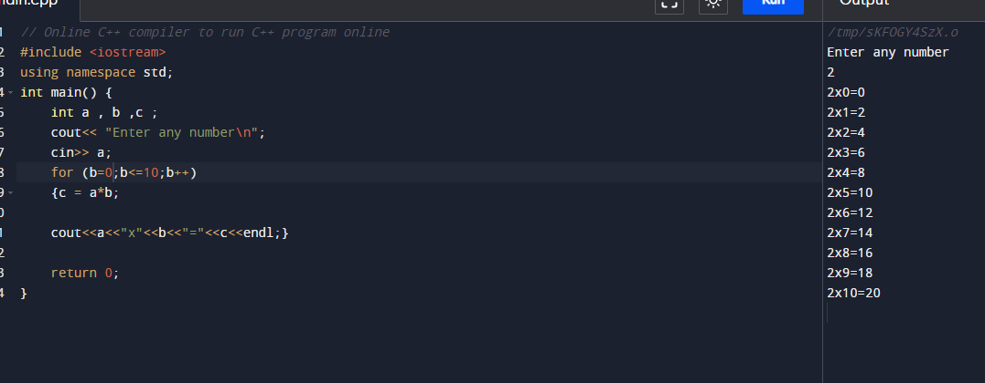Write a C++ program to Print a Table of any Number.

#include <iostream>

using namespace std;

int main() {

int a , b ,c ;

cout<< "Enter any number\n";

cin>> a;

for (b=0;b<=10;b++)

{c = a\*b;

cout<<a<<"x"<<b<<"="<<c<<endl;}

return 0;

}

3.Write a Program to Generate Factorial.

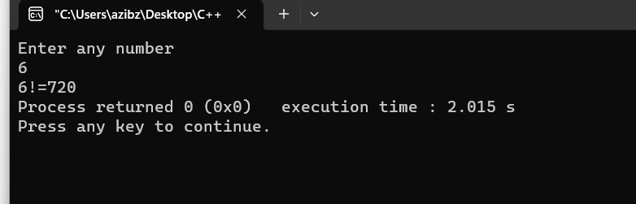

#include <iostream>

using namespace std;

int main() {

int x,a,b=1;

cout<<"Enter any number\n";

cin>>x;

if(x>0)

{ for(a=1;a<=x;a++)

{b=b\*a;}

cout<<x<<"!"<<"="<<b;}

else if (x==0)

{cout<< "0!=1";}

else {cout<<"Factorial doesnot exist";}

return 0;

}

4.Write a C++ program to generate a Fibonacci sequence up to a certain number input by the user.

#include <iostream>

using namespace std;

int main() {

int a,b ,c ,y;

cout<< "Enter any 2 Fibonacci number\n";

cin>> a>> b ;

cout<< "Enter index number\n";

cin>> y ;

cout<< "Fibonacci sequence till index number"<<y<<endl;

for (int x=0 ;x<y;x++)

{ c=a + b ;

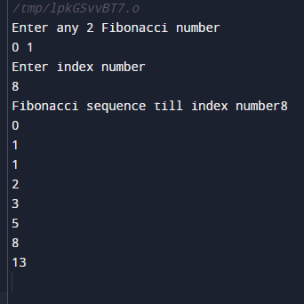 cout<<a <<endl;

a=b ;

b=c;

}

return 0;

}